**UNIT 1: ART**

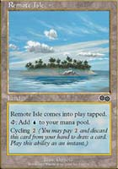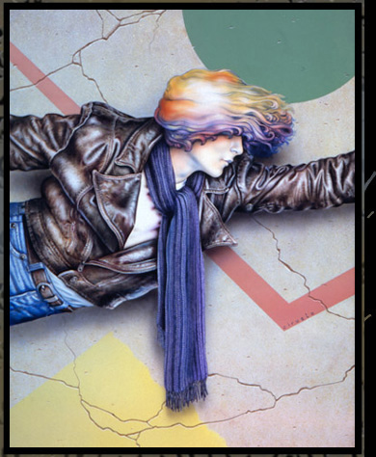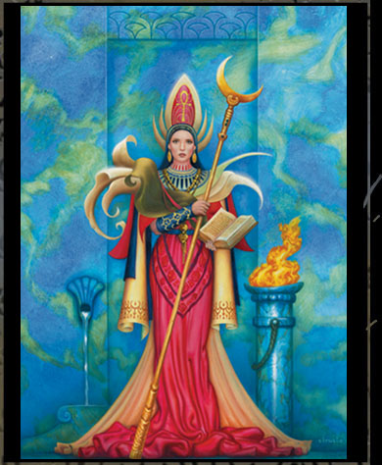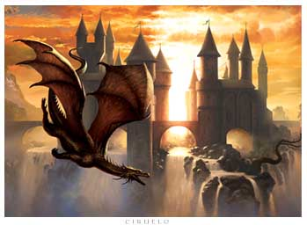

1. Which of the following artists do these images belong to?

1. J.R.R. Tolkien
2. Ciruelo
3. J.K. Rowling
4. Caloi

2. What would you like to know about Ciruelo? Make a mindmap with CMapTools with questions about him. Work in groups.

3. Now, read his biography. Can you find the answers to your questions?

The Lord of Dragons

Ciruelo (his real name is Gustavo Cabral) is from Buenos Aires, Argentina. His birthday is on July 20th. He is an illustrator and fantasy artist. He lives in Sitges, Spain, an attractive and magical town near Barcelona, on the Mediterranean Sea. He lives with his wife, Daniela, and their two children, Angelo and Lys.

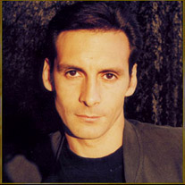

At 13 he studies advertising design and illustration at the prestigious Instituto Fernando Fader. At 15 he publishes his first drawing in a school magazine and at 18 he starts working as an illustrator in an advertising agency. At 21 he becomes a freelance illustrator and starts his career as a fantasy artist.

He defines an illustrator “as an artist that applies his work to a text or to the ideas of another.” Now he is his own illustrator, he creates his art only for his own ideas and texts. His favourite painting technique is acrylic, with a brush on canvas, but he also uses an airbrush and a paintbrush for details. At present he is using oil on canvas. He hardly ever uses computers to work but he thinks they are of great help especially to save time.

His style is “fantasy”. He works with medieval fantasy, elves, dragons, fairies and other images from Anglo-Saxon, Nordic and Celtic folklore. Literature and music are of great influence to him. His imagination develops in contact with nature, love, music, dreams, kids, fire, the clouds and many other things.

He publishes art books on his own and works for American publishers. One of these publishers is Bantam, and Ciruelo did the book covers for the trilogy “*Chronicles of the Shadow War*” by George Lucas. He also illustrated some of the cards in the card game *Magic Wizards of the Coast*. In 2010 he published *Dreams Notebook*, a book in which he expresses his personal visions.

He also does some album covers. His most famous ones are on some albums by Marcelo Torres, Luis Alberto Spinetta, Enanitos Verdes and Steve Vai. When he works, he usually listens to Pat Metheny Group, Steve Vai, Spinetta, Seal, Lito Vitale, Silvio Rodríguez, Jeff Beck, David Bowie and classical music. He writes some music too.

He often travels to different countries putting up exhibitions of his works and presenting his books. He enjoys travelling. One of his favourite places is the Patagonia in Argentina.

Believe it or not, he is colour-blind! He can´t distinguish some colours and confuses some others.

A. Read the text and answer

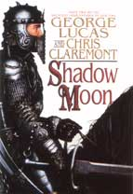

1. How does he define an illustrator?
2. Does Ciruelo work only for himself? Why/why not?
3. What techniques does he use?
4. Does he use computers?
5. Does he only paint?

B. Find in the text…

1. one usual activity Ciruelo does.
2. one particular characteristic about him.
3. one of his famous works.
4. some cultures he uses for his works.

C. In groups, create a timeline with Ciruelo´s most important life events. Use thissite: <http://timerime.com/es/>

D. Now, match the headings with the paragraphs of the biography.

1. The artist and his materials. paragraph ____
2. His beginnings paragraph ____
3. His art and inspiration. paragraph ____
4. Not only books… paragraph ____
5. Famous works. paragraph ____
6. Who´s the Lord of the Dragons? paragraph ____
7. His own sales representative. paragraph ____

The Art of Ciruelo

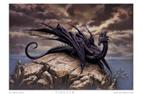

4. Ciruelo uses some of these techniques. Which ones are in the biography? Tick them in the chart. Then, match the techniques with their descriptions.

|  |  |
| --- | --- |
| 1) Oil on canvas | a) Art which represents images from our surrounding world. These images can be exact or unreal. |
| 2) Petropicts | b) The use of a brush and special paintings to paint on canvas. |
| 3) Collage | c) It is [three-dimensional](http://en.wikipedia.org/wiki/Three-dimensional_space) [artwork](http://en.wikipedia.org/wiki/Visual_arts) created by shaping hard or [plastic](http://en.wikipedia.org/wiki/Plastic) material, commonly [stone](http://en.wikipedia.org/wiki/Stone_sculpture) (either [rock](http://en.wikipedia.org/wiki/Rock_(geology)) or [marble](http://en.wikipedia.org/wiki/Marble)), [metal](http://en.wikipedia.org/wiki/Metal), or [wood](http://en.wikipedia.org/wiki/Wood). |
| 4) Digital art | d) It is a genre of [art](http://en.wikipedia.org/wiki/Art) that depicts [magical](http://en.wikipedia.org/wiki/Magic_(paranormal)) or other [supernatural](http://en.wikipedia.org/wiki/Supernatural) themes, ideas, creatures or settings. |
| 5) Acrylic on canvas with brush | e) It is the art of painting on stones |
| 6) Giclee prints | f) This technique consists of making a picture by sticking different materials or objects into a surface. |
| 7) Airbrush | g) The use of computer software (for example Photoshop) to make or manipulate artworks |
| 8) Figurative art | h) An artwork made on a piece of fabric of cotton or similar material and painted with oil paints. |
| 9) Fantasy Art | i) High Quality prints which are typically created using professional 8-Color to 12-Color ink-jet printers. |
| 10) Sculpture | j) The use of a special brush. This brush is an atomizer using compressed air to spray a liquid, such as paint, on a surface. |

5. Do you know any other art techniques? Ask your art teachers and look for examples of them. Present them to the rest of the class using the digital tool you prefer.

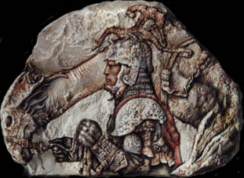

6. Petropicts

Ciruelo created this technique when he gave a stone from the Andes Mountain Chain to a friend and tried to sign it.Watch the video in the section *Petropictos* on Ciruelo’s official site (<http://www.dac-editions.com/petropic.htm>) and put the descriptions in order:

1. _____ Ciruelo goes to the mountains and walks around.
2. _____ Ciruelo paints directly on the surface of the stone following the stone´s natural configuration.
3. _____ He discovers three-dimensional images of animals and human beings on the stones.
4. _____ He takes the stones home.
5. _____ He draws a sketch of the image he will paint on the stone.

7. Let´s learn some vocabulary related to the world of fantasy. Match the words to the pictures: castle, princess, hill, cave, warrior, wizard, treasure, sword.

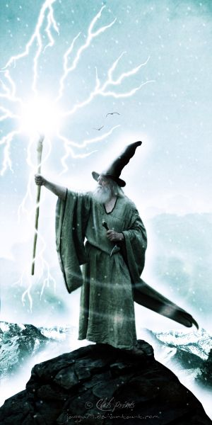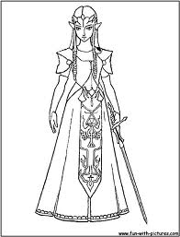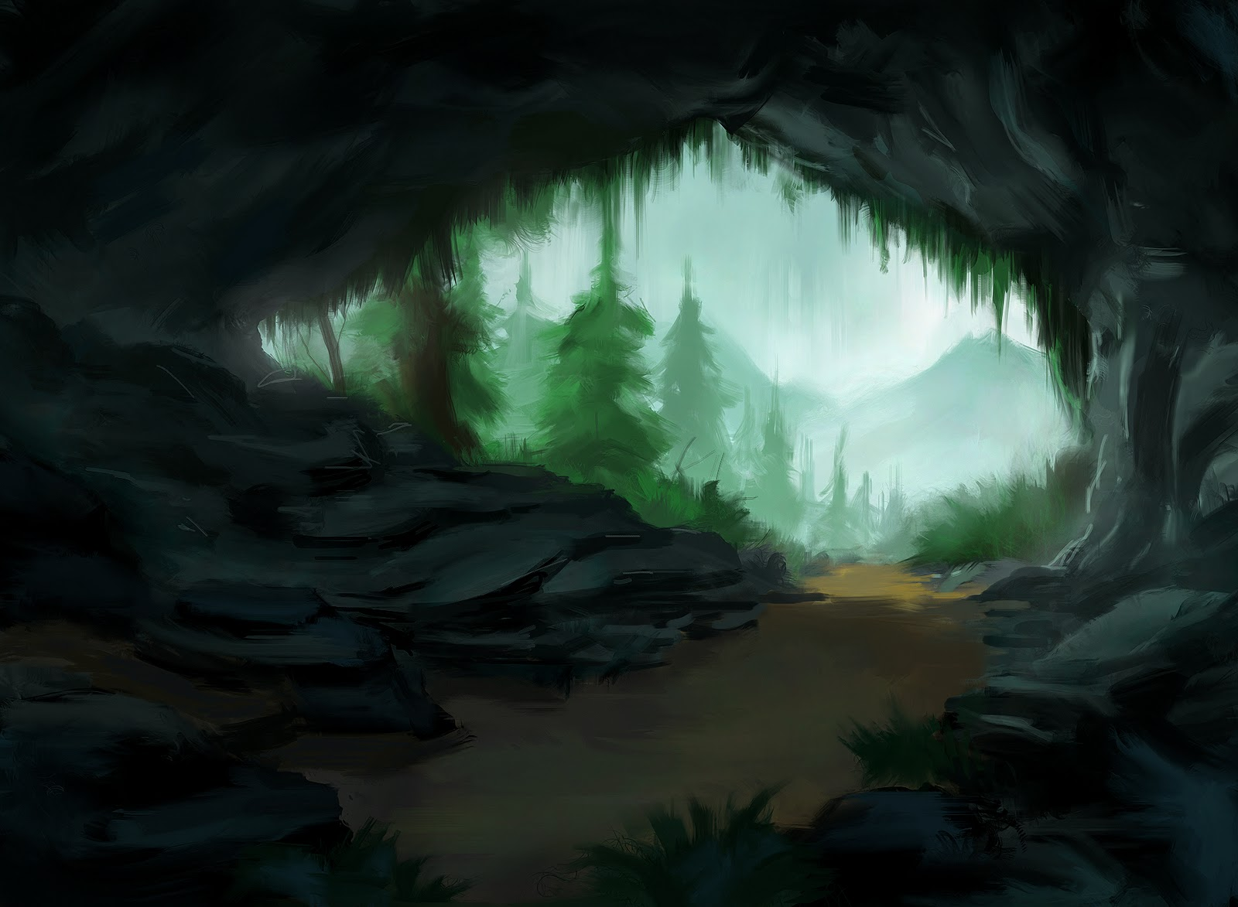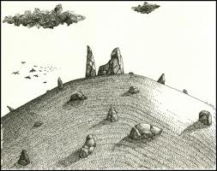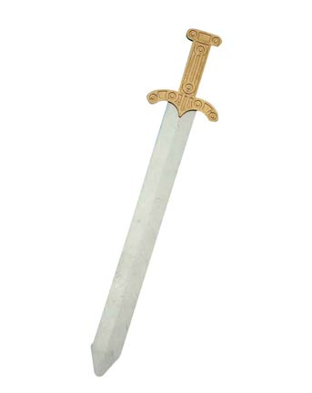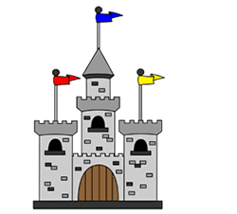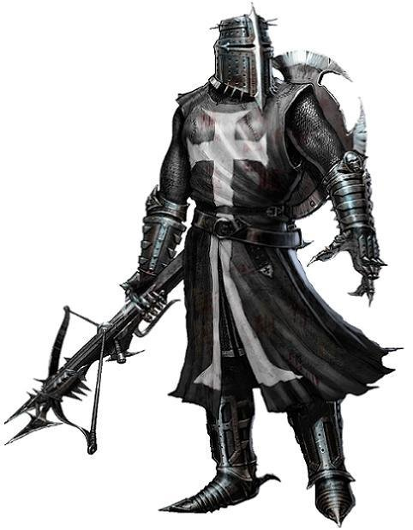

8. Now, try to use some of these words to complete the description of the following pictures.

Sunset Dragon



There is a ________ in the picture. It is flying near the _______. The sun is setting down. There are cold and warm colours in the picture...

Fafner and Sigurd

There is a _______ and there is also a dragon. They are in a ________. The dragon isn´t flying. The warrior is holding a ________. He´s wearing a helmet and an armour. There´s a ________ in the cave, too.

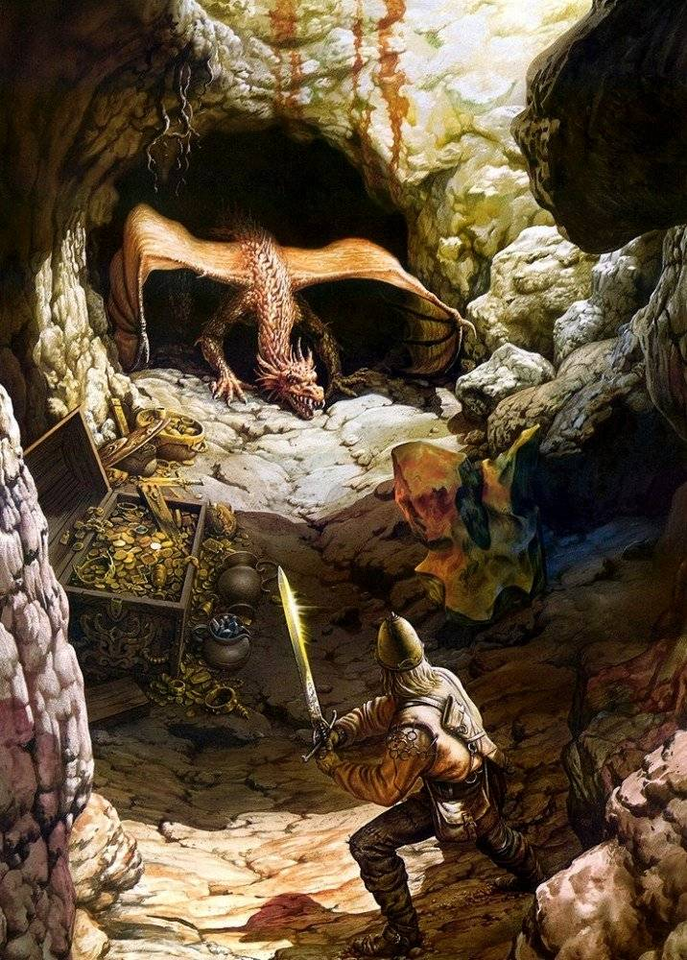

Fantasy lake

Which of the words from the previous exercises can you use to describe the picture Fantasy Lake? Use a dictionary and find more possible words.

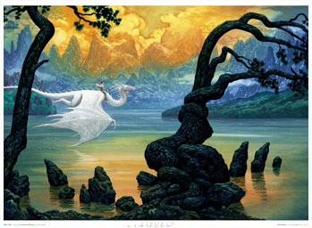

Choose one of the following pictures and write the description. Use the words you learned and add more if you need.

Crusade

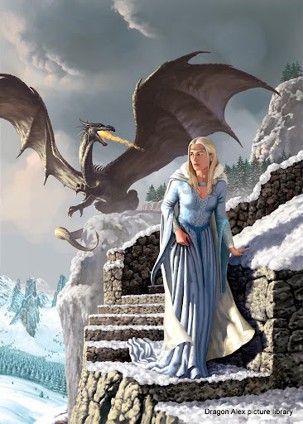

Elminster

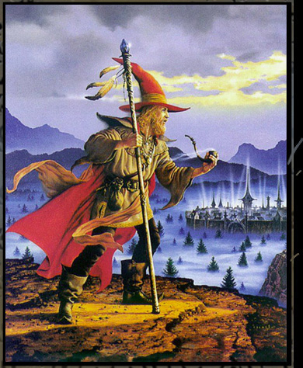

9. Choose one of the following options

1. Use the ideas in the descriptions of Ciruelo´s paintings and match the following sentences using: *and, but,* and *so*.

|  |  |  |
| --- | --- | --- |
| The princess is scared  The dragon is looking after the treasure  the man on the hill is a wizard  the dragon kills the warrior | And | The princess is escaping.  The treasure is for the people  he is waiting for the dragon  the warrior kills the dragon |
| But |
| So |

B) Or you can create your own comic strip with the ideas in the descriptions of Ciruelo´s paintings. Include bubbles in the first comic or create your own comic for the second option. Present the final version on paper or a digital poster.

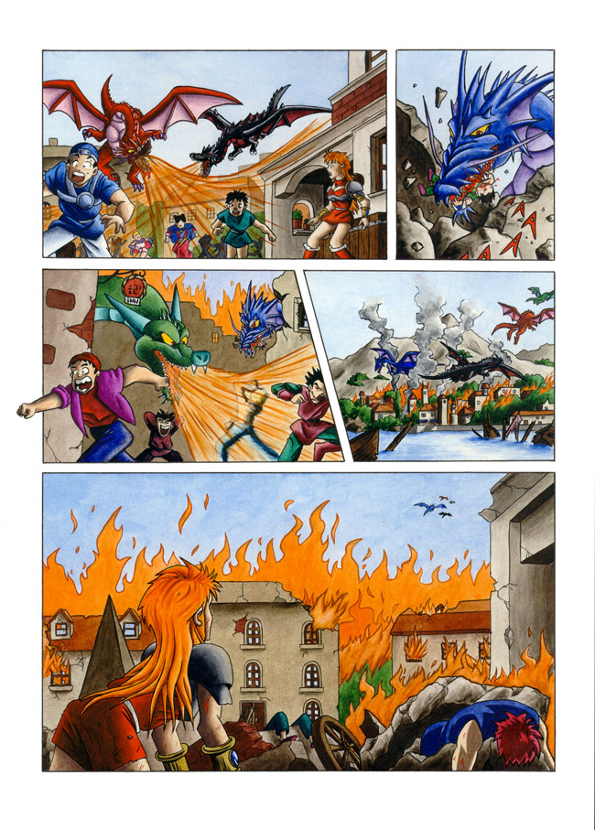

1.

2.

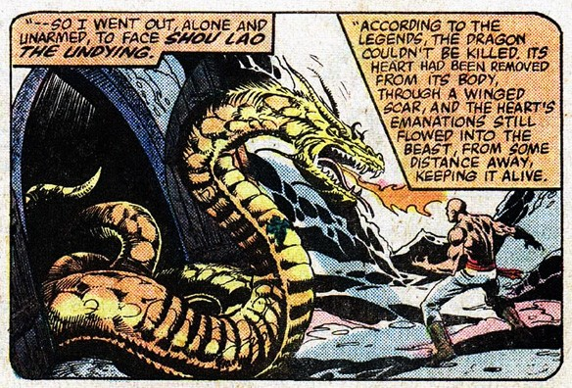

10. Now, let´s watch an interview with Ciruelo. Go to this site: <http://www.youtube.com/watch?v=vxZR-SgMut4>

Listen and complete the artist´s answers.

**Interviewer**: Hello Ciruelo, how are you?

**Ciruelo**: Fine, William, thank you.

**Interviewer:** Thank you for coming to Norwescon 31 here.

**Ciruelo**: Well, it´s been an honor for me to be here, of being part of this edition of Norwescon, I´m really _________to be here.

**Interviewer:** We´re extremely happy to have you here, such a talented artist. The people here have just loved your work, hopefully not only have you had a good time but a profitable time too, have you?

**Ciruelo:**Yes, of course. It´s always great to be in touch with public for me. As an artist I’m always ______________, by myself working in my ___________, so these are the opportunities for me to ____________ with people and to have some feedback.

**Interviewer:** You are passionate about the environment, you love trees and mountains, I hope you´ve found (*Washington a* ) view, have you?

**Ciruelo:** Yeah, of course, I __________ this area and I hope to come back soon to do some visiting around the__________, only ____________ mountains and the rest, you know.

**Interviewer**: You got a couple of days to go down to Seattle, didn´t you?

**Ciruelo:** Yes, and I really enjoyed the city, I loved it. Well, of course, ____________ ___________ _______________, of course, also I´ve been at the ___________ ____________, which I´ve found very interesting. I really loved the city.

**Interviewer:** I’m glad you´ve had a good time. So you, is there any part of Norwescon itself that actually sticks out of your mind?

**Ciruelo:** Well, actually, the contact with the people is always the best part of any show. Of course, this show I like it specially because it’s very…it’s like a family, it’s very …people here is very friendly and it’s easy to get closer to organizers and the people who work here which is not the same thing in other conventions which are bigger. So that I really enjoyed a lot.

**Interviewer:** You have a new book coming out pretty soon?

**Ciruelo**: Yes, it’s yes, it’s a book that I’ve been writing and illustrating for about two years and a half and it’s called *_______________ _____________ _____________, ____________ _____________ __________*the subtitle, and it will be out in July 2008

TAPESCRIPT:

Interviewer: hello Ciruelo, how are you?

Ciruelo: fine, William, thank you.

Int: thank you for coming to Norwescon 31 here.

Ciruelo: well, it´s been an honor for me to be here, of being part of this edition of Norwescon, i´m really **happy** to be here.

Interviewer: we´re extremely happy to have you here, such talented artist. The people here have just loved your work, hopefully not only have you had a good time but a profitable time too, have you?

Ciruelo: Yes, of course. It´s always great to be in touch with public for me. as an artist I’m always **alone**, by myself working in my **studio**, so these are the opportunities for me to **get in touch** with people and to have some feedback.

Interviewer: you are passionate about the environment, you love trees and mountains, I hope you´ve found (*Washington a* ) view, have you?

Ciruelo: yeah, of course, I **love** this area and I hope to come back soon to do some visiting around the **city**, only **big** mountains and the rest, you know.

Interviewer: you got a couple of days to go down to Seattle, didn´t you?

Ciruelo: yes, and I really enjoyed the city, I loved it. well, of course, **Pike Place Market,** of course, also i´ve been at the **Art museum**, which i´ve found very interesting. I really loved the city.

Int: i´m glad you´ve had a good time. So you, is there any part of norwescon itself that actually sticks out of your mind?

Ciruelo: well, actually, the contact with the people is always the best part of any show. Of course, this show I like it specially because it’s very…it’s like a family, it’s very …people here is very friendly and it’s easy to get closer to organizers and the people who work here which is not the same thing in other conventions which are bigger. So that I really enjoyed a lot.

Int: well, you’re too kind and you’re family, hopefully you´ll be coming back. You have a new book coming out pretty soon?

Ciruelo: yes, it’s a book that I’ve been writing and illustrating for about two years and a half and it’s called ***Fairies and Dragons, Magic is Art***, the subtitle, and it will be out in July 2008

Int: that’s this year?

Ciruelo: yes this year. It’s going to be the first of a series because actually I love to write and illustrate so I will keep on doing that. For a while.

Int: well thank you very much for being here, you´ve been an excellent guest. We´ve had obviously a great time. You´ll be invited back some time in the future, hopefully you’ll be able to come back and hopefully spend a little more time with us

Ciruelo: yes I hope so, thank you very much William, thank you to Tracy and I wanted to..since my English is not that good, I wanted to talk in another language that I really know better, which is first of all

(rose) Thank to all the people from the Norwescon team

(bells & books) To the edition of Bells book and dragons

(smiley) i´m very happy to be here.

(heart) and also with all my love, for you all

Interviwer: thank you Ciruelo

Ciruelo: you´re welcome

11. PROJECT

1. Choose any other plastic artist and write an interview. Use a minimum of five questions. Choose from the following questions or create your own.
2. Where do you live?
3. What´s your favourite material?
4. What inspires you?
5. What do you like doing in your free time?
6. When and how do you create?
7. Can you describe your favourite work of art?
8. Who do you admire?
9. What style do you like best?
10. Are you interested in any other type of art?
11. Do you sell a lot of your works?
12. Present your interview to the class. Choose one of the following: a video, an audiorecording or role-play

My glossary

Write all the words in teh unit connected with Art

|  |  |  |
| --- | --- | --- |
| ***Spanish*** | ***English*** | ***French*** |
|  |  |  |